**Critical Play Report – *The Witness***

Composer: Gordon (Cunbo Li)

Email: [gordon.lee@nyu.edu](mailto:gordon.lee@nyu.edu) or [cl3846@nyu.edu](mailto:cl3846@nyu.edu)

*The Witness* is one of my most favorite puzzle games because it has so many interesting puzzles and its gameplay of non-verbal communication.

First of all, puzzles are the main and most important part of the game, of course, this is a puzzle game. In the game, the player will realize the puzzles are gradually more and more difficult. Puzzles at the most beginning of the game are designed as tutorials, which is using for training the player how to find out the target of each puzzle and figure out the solution. For example, yellow puzzles (showing in Figure01) are just using for training the player. They are the easiest puzzles in the whole game. When the player solves a puzzle on the panel, the wire connects between the current panel and next one will lighten up and guide the player towards to the next puzzle. This design matches the mechanics of “Non-verbal communication” in the gameplay. That is to say, game objects will navigate the player walk through the whole game, rather than a text or text hint. With all the yellow puzzles are solved, the player is able to open the gate and enter into the next part of Entry Area. Entry Area has two parts, the first area is what we just talked about – yellow panels, the second area is also for training but more difficult than the first area. The color of panels distinguishes the category of puzzles. Puzzles on the blue panels (showing in Figure02) are called Black & White Squares, the target of these puzzles is separating black and white squares with the line the player was drawn. Puzzles on the green panels (showing in Figure03) are Hexagon Dots, which are solved by intersecting all the hexagon-shaped dots with the line and reach the end position. By solving these puzzles, the player will recognize puzzle types and quickly realize the target of varied puzzles. Puzzles in the game are quite difficult to solve, the player should spend more time to figure out the solution. If the player would just quick explore the game world, checking the Walkthrough articles is also a good choice for playing this game.

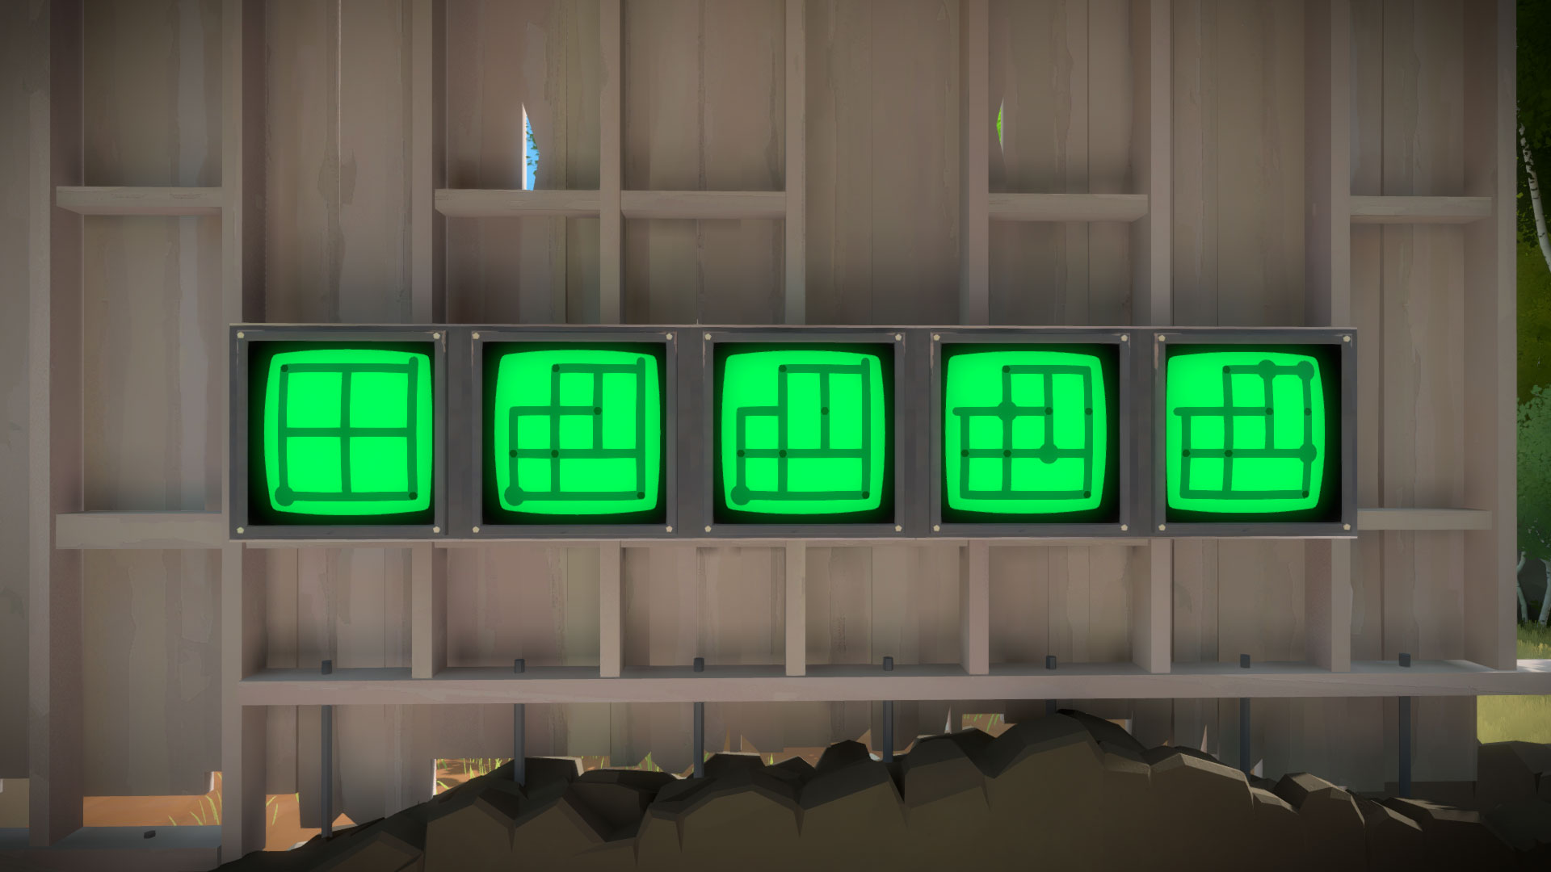

Firugre03

Firugre02

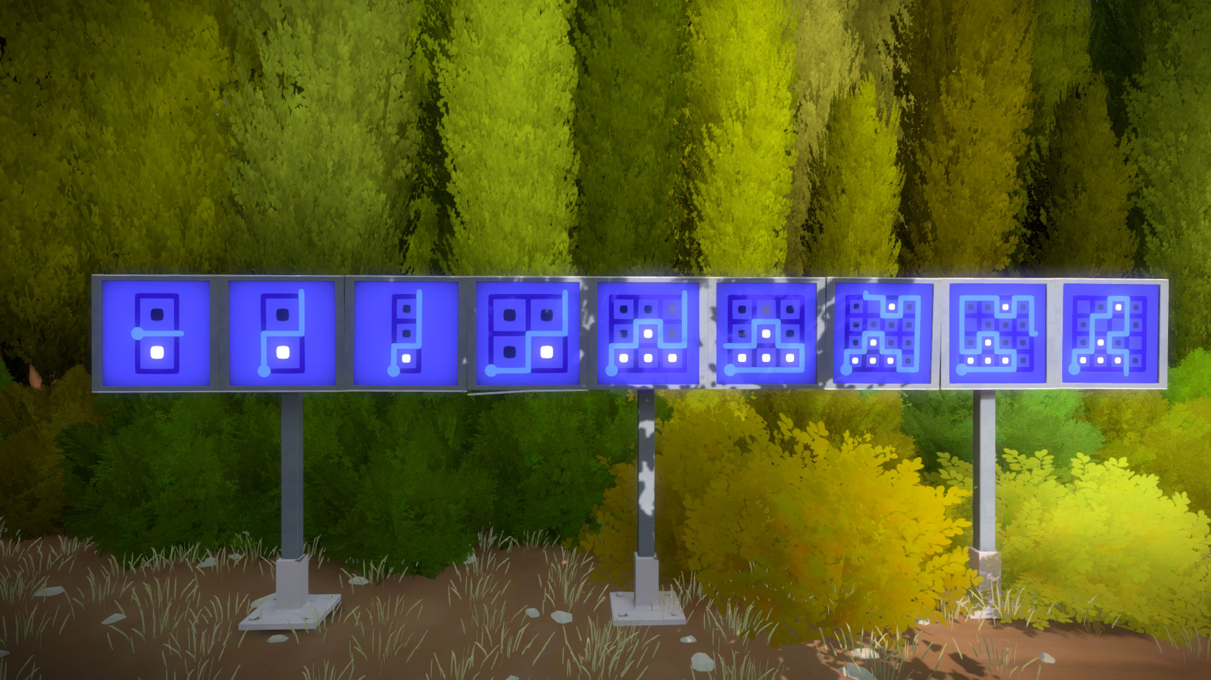

Firugre01

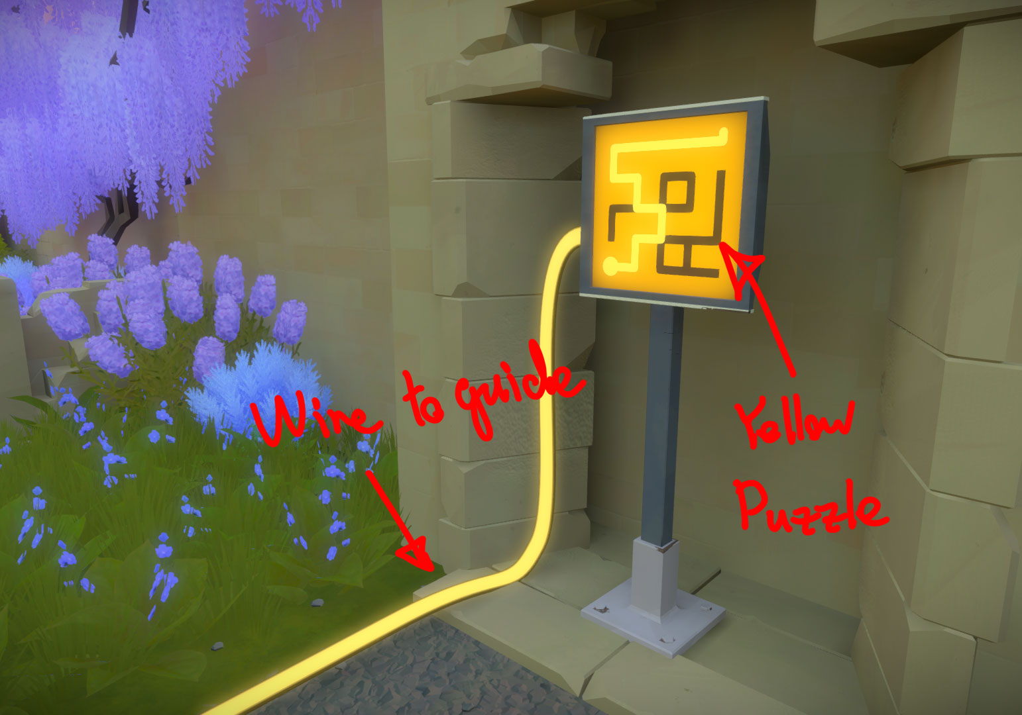

Besides the puzzles in *The Witness*, the gameplay is another well-designed part of the game. The designer chose “Non-verbal communication” to guide the player follows the main path in the game. Wires connect between panels are linear guidance, which means the player follows the wire to reach the next puzzle. The environment sometimes hides clues of the puzzles. For instance, the puzzles are scattered in pink trees area. The player needs clues from apple position on apple trees to solve puzzles. As Figure04 showing, the apple is on the right of the sixth branch of the apple tree, so that the solution of this puzzle is reaching the apple’s relative position on the panel. After the player solves the puzzle, the wire will lighten up and guide you the next puzzle. So the gameplay of *The Witness* not only solve puzzles but also inspect more about the environment and find out useful information or hint that hidden in the surroundings.

Firugre04

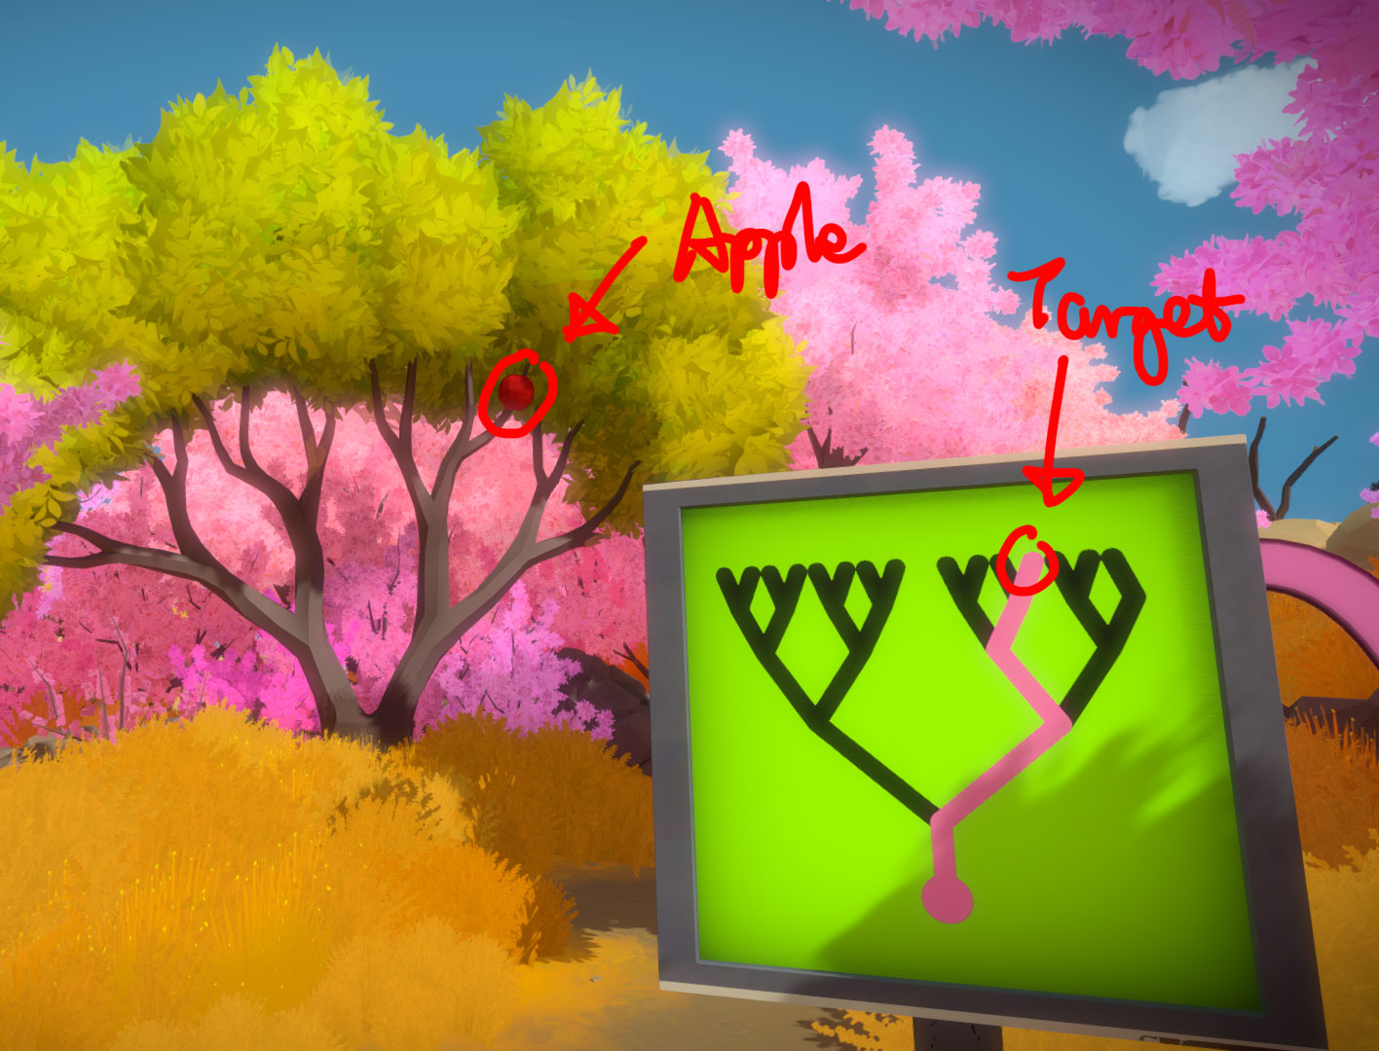

In summary based on the above discussion, I believe that *The Witness* is the most interesting puzzle game that I’ve ever played. Not only with such beautiful game art, but also because of the puzzles in the game and the gameplay of “Non-verbal communication”. This game is a great example of puzzle game design and a lot of details should deeply study and analyze.